**LT2204 Language and Mind**

**Word Association and Word Games**

**HE Songjun Sherry (5438 0998)**

**WAN Yuwei Mia (5438 2027)**

**Introduction**

The term word association is a common practice in linguistics to classify words not only on the basis of their meanings but also on the basis of their co-occurrence with other words (Church, K. W., & Hanks, P, 1990). Vocabulary is always identified the most important thing among language learners and word association plays a necessary role in the process of learning words. In our report, an experiment of word association will be conducted and we will investigate this linguistic phenomenon by using the theory of mental lexicon in the discussion part. Finally, two word games created by us will be introduced and the resources of the games are the word responses which were collected by the participants from the experiment.

**Aims of the Word Association Experiment**

An essential aspect of knowing a language is knowing the words of that language. This knowledge is usually thought to reside in the mental lexicon, a kind of dictionary that contains information regarding a word's meaning, pronunciation, syntactic characteristics, and so on. (Elman, J. L, 2004) By conducting this experiment, we aim to analyze the semantic connection between words stored in participants’ mental lexicon according to the responses given by them. After analyzing how one word stimuli triggers off word responses, we strive to design two word association games based on the data we collect and how our mental lexicon works to facilitate English learners with a vocabulary learning tool.

**Methods of the Experiment**

First, 15 frequently used words including 5 nouns, 5 verbs and 5 adjectives are chosen. These words are not related with one another. These 15 words are listed as below:

Nouns: 1. apple 2. nose 3. bird 4. star 5. paper

Verbs: 1. go 2. act 3. love 4. stand 5. touch

Adjectives: 1. cold 2. smart 3. old 4. dark 6. hungry

These words are read aloud to the participants one by one. After hearing each word, the participants responded what word came in their mind first. Then, we generated a list of words for each word stimulus with responses given by the participants.

The target participants of this experiment are university students aged 17 to 22, whose mother language is Mandarin with English as their second language. We conducted this experiment with 60 participants for analysis.

**Results and Discussion**

Apple: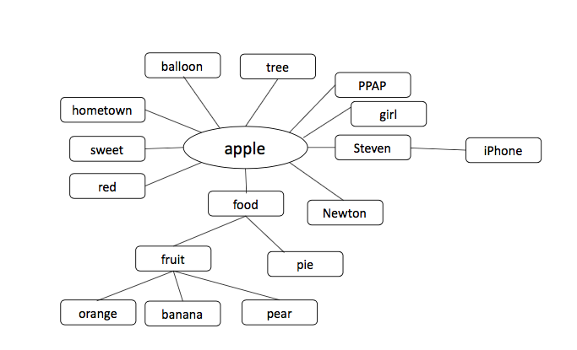

***Attributive*** relationship and ***coordinate (hyponymy)*** relationship appear most frequently each with a frequency of 20 times. ***Collocation*** relationship is the third frequent one with a frequency of 16 times. ***Superordinate (hyponymy)*** has 6 times. Among the words, iPhone and Steven Jobs are mentioned partly because of the popularization of smartphone, especially among university students. Interestingly, “hometown” is given because the participant’s hometown is Shandong Province, where is famous for high quality apples.

Nose: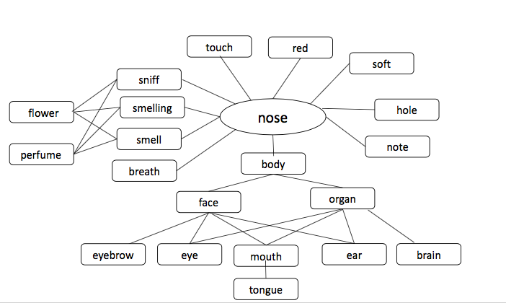

The most frequent semantic relationship is ***coordinate (hyponymy)***. Such relationship appears 35 times in total, bearing different facial features. ***Collocation***, ***functional relation, part -whole relation and attributive relation*** appear less frequently, with frequencies 5, 4, 3, 2 respectively. One ***phonological reason*** is noticed from the response “note”. They have similar pronunciation that one is [noʊz], the other is [noʊt].

Bird: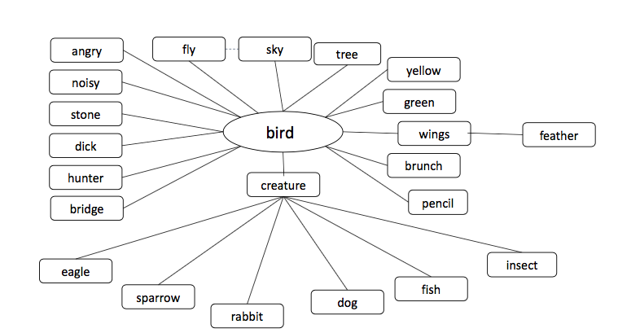

***Functional relation*** appears most frequently with a frequency of 25 times. ***Collocation relation*** appears 18 times. ***Attributive and part-whole relation*** appear less frequently with the frequency of 5 and 2 respectively. Within the ***hyponymy relation, superordinate, coordinate and subordinate relation*** appear once, four times and twice respectively. Technology trace can also be found here, the popular phone game “Angry Bird” contributes to the response. Besides, mother language plays a role in the response “stone” because of the idiom “一石二鳥”.

Star: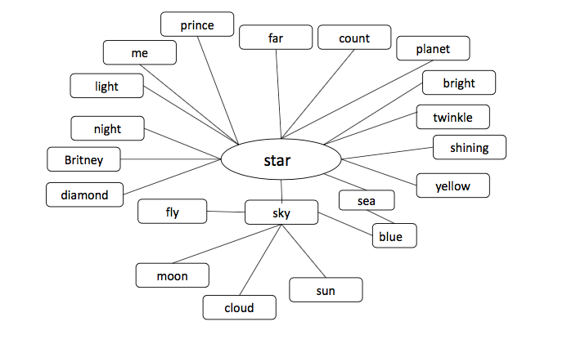

Only two kinds of relationships are raised by the participants’ responses. One is ***collocation*** relation, whose frequency is as high as 45 times. ***Attributive*** relation has a frequency of 18 times. Because of the semantic meaning of the word as well as the participant is young students, celebrity is mentioned as “Britney”. Meanwhile, one of the participant’s name is “star”. Therefore, her response is “me”.

Paper: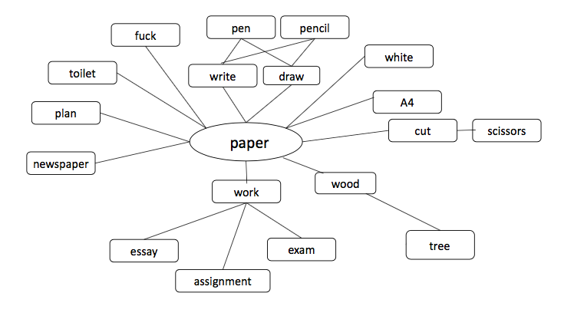

The most frequent semantic relationship is ***collocation***, with 44 occurrences. ***Attributive*** relationship and ***synonymy*** relationship appear less frequently, with frequencies 14 and 6 respectively. The least appearance relation is ***functional*** one, which only appears twice.

Go: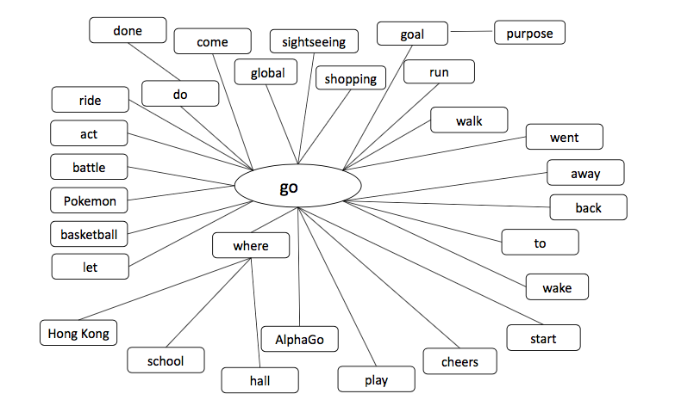

***Collocation*** relation ranks highest with a frequency of 47 times. ***Antonymy*** relation comes the next with 10 times mentioned. ***Phonological*** reason and ***synonymy*** reason appear only once respectively. The influence of modern technology is shown by the response “Pokémon”, which is the popular phone game and “Alpha Go”, the high-tech robot.

Act: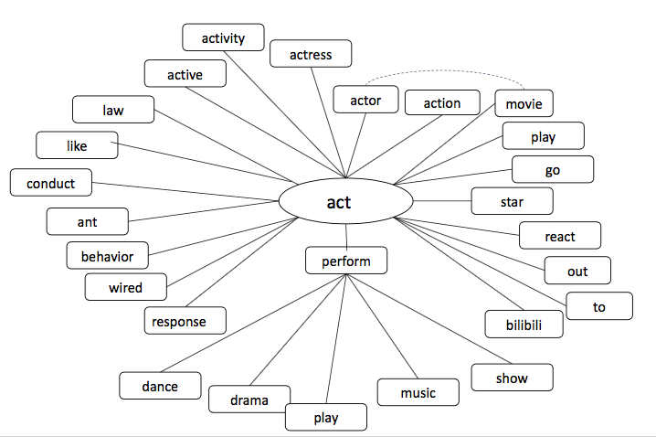

***Collocation*** appears most frequently with a frequency as high as 54 times. ***Synonymy*** relation appears 5 times. ***Subordinate (hyponymy)*** and ***phonological relation*** appear only once for each relation. Because one of the participants is in Law School, his interpretation of the given word is the law term. Therefore, his response is “law”. “Bilibili” is a popular video website among young people in mainland China. Because one of its slogans is related to “act”, the influence spreads to the participant’s mental lexicon.

Love: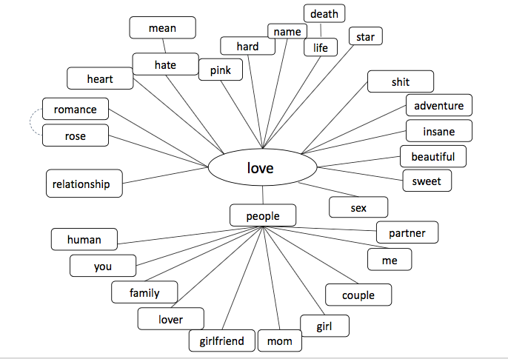

The most frequent relation is ***collocation*** which appears 37 times and ***antonymy*** follows with 13 times’ appearance. ***Attributive*** relation appears 5 times and ***functional relation*** appears 4 times. Then ***superordinate (hyponymy)*** only appears once.

Stand: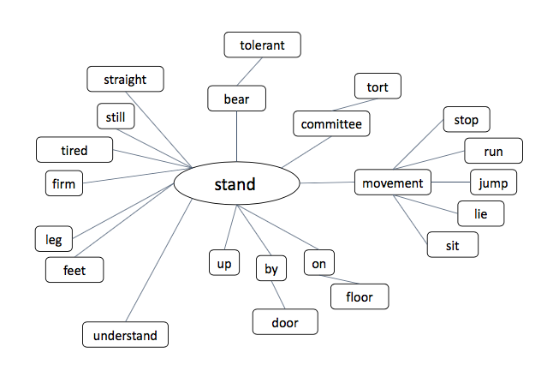

***Antonymy relation*** appears most frequently with 29 times and ***collocation*** follows with 20 times. ***Attributive*** relation appears 4 times, while ***superordinate(hyponymy)*** appears once. ***Functional relation*** and ***synonymy*** relation both appear twice. ***Phonological relation*** appears only once. “tort” and “committee” come from some law students among our participants.

Touch: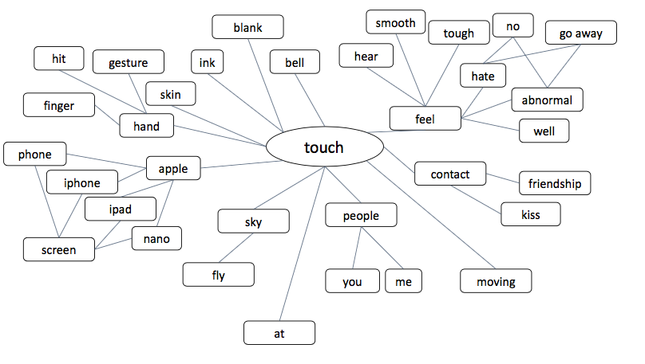For the word “touch”, only three kinds of relation come up. The most frequent one is ***collocation***, with a repetition of 55 times. And the middle frequent one is ***functional relation*** which appears three times. The least frequent one is ***synonymy*** with only twice. The words about products of Apple and Apple itself appear 9 times which shows the influence of popular high-tech brand Apple among students.

Cold: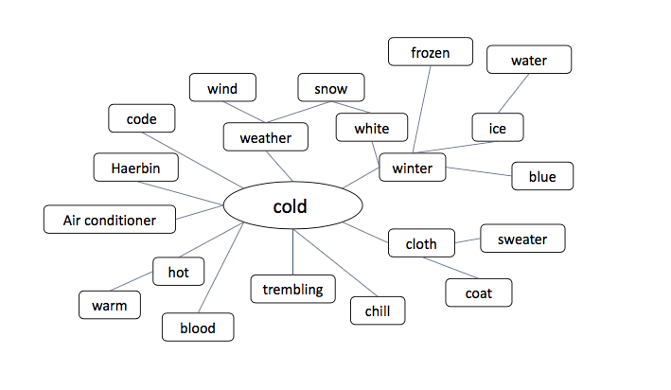 ***Antonymy*** has the highest frequency with 29 times and ***attributive*** appears 16 times. ***Collocation*** also occupies a certain proportion with 10 times. ***Phonological relation*** appears twice while ***superordinate(hyponymy)*** and ***synonymy*** only appear once respectively. Here comes a northern city in mainland China called “Ha’erbin” which is very cold in winter.

Smart: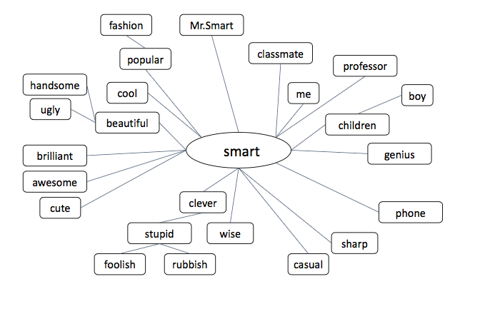***Attributive*** appears 20 times as the relation of the highest frequency. ***Antonymy,*** with the appearance of 16 times has a similar frequency as ***synonymy*** which appears 15 times. ***Collocation*** appears 9 times as the lowest one. The response “phone”, which appears 5 times, shows the influence of technology nowadays. And “Mr. Smart” is a character in textbooks of primary school in some areas of mainland China.

Old: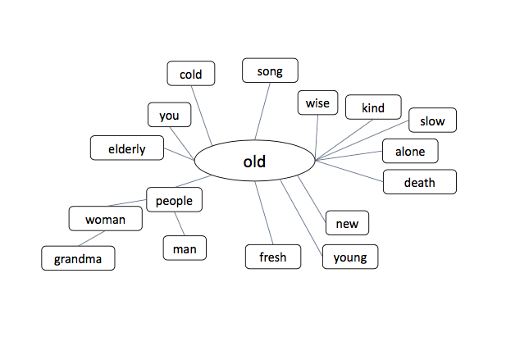

***Antonymy*** has 35 times as the greatest number of appearance among all the relations and the second one is ***attributive*** relation, with 15 times. ***Collocation*** has 6 times but ***phonological*** only has one time.

Dark:

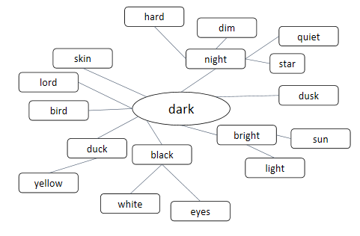

***Collocation*** becomes the most frequent relationship with 27 times, and decreases from ***attributive, antonymy, phonological relation*** and ***synonymy*** with 17, 12, 3and 1 times. “bird” comes from the association of raven.

Hungry: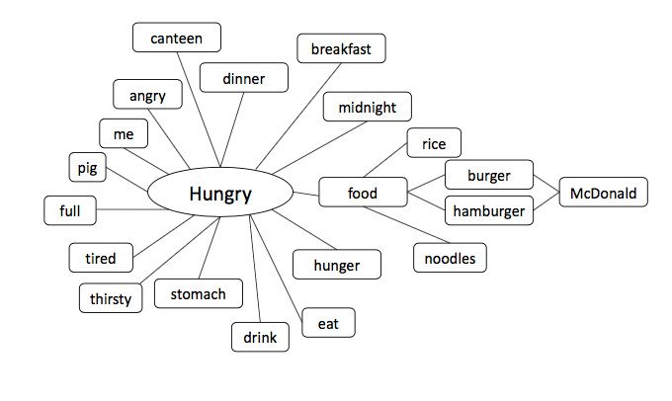

The most frequent relation is ***collocation***, with a repetition of 49 times. The less frequent relations are ***coordinate(hyponymy), antonymy*** and ***attributive,*** which occur 4, 4, 2 times respectively. Lastly, ***phonological relation*** appears least frequently, with only one occurrence. As students in university, participants give us some words from the environment they are familiar with such as “canteen” and “McDonald”. “Rice” and “noodles” also appear as ordinary food in China.

**Creation of Word Games**

Word Association Guess Word Game

1. Target player

Learners who are in their elementary stage of learning English.

2. Number of players

The number of players can range from one player to several players. If there are more than one player involved, the game will convert into battle mode between or among players. To keep the game interesting and organized, 10 players is the maximum.

3. Instructions

In total, 15 sets of words are used. Each set includes a “core word” and dozens of “related words”. In total, there are 335 related words. On average, each core word has 22 related words. One set of words is used for one round. The core words are the ones given in the headings in Appendix 1. The related words are the ones listed as “response” in Appendix 1.

4. Playing method

Three related words will be given initially. One more related word will be given every minute when the game keeps going. The same numbers of blanks as the core words’ length are also given. Based on the given related words and the word length hint, the player makes a guess at what the core word is. The game starts timing as soon as the related words are shown to the player. If the player can have the correct answer in one-minute time, he or she can gain all five coins. Every one more minute is cost, one more related word is given. Meanwhile, the coin will decrease one as a penalty. If there is one player, after 15 rounds, if the coins he or she gained are more than 60 coins, the player wins. If there are more than one player, there will be a battle mode between or among players. In battle mode, every round, the one who earned least coins will be eliminated. The one who gains the most coins till the last round is the winner of the game. There is a sample interface in Appendix 2.

5. Aims of the game

This game aims to make use of the mental lexicon’s word association to stimulate related words as well as the core words. Thus, the familiarity and semantic relation of the words will be enhanced to let the players have a better and deeper understanding of the words in a relaxing way through games.

Word Association Link Game

1. Target player

Different levels of the words can adapt to different levels of English learners. And this following example is for primary students because of the words we used in our experiment.

2. Number of players

The number of players depends on the state. If there is only one player involved, the player can use the “Single Mode” with a set of cards. If there are more than one player involved, the game will convert into “Double Mode” or “Multi-player Mode” with several sets of cards. For convenience, the best choice is “Double Mode” and it’s better not to have more than 5 players for “Multi-player Mode”.

3. Instructions

There are 5x16=80 cards in one set of cards. Each card has a word on the front and decorative pattern on the back (or just blank). We pick 5 different kinds of relations in word association to form the 5 levels of the game, which are Synonymy, Antonymy, Attributive, functional relation and Collocation. In total, there are 5x8=40 pairs of related words (each level has 8 pairs). Players can use the same principle to make new cards with new words or other kinds of word association for further learning.

4. Playing method

Before every level start, 16 cards will be back up on a flat place in 4x4 style. The player can turn over the card to see the word after the game start. Two cards can be kept face up at the same time and if the player wants to turn over another card, one of the two cards should be turned back up. Only can the player wipes out two cards when he or she finds out one pair of related word and turns over them face up at the same time. The positions of other words will not change until the player wipe out all the cards. The player should find out the pairs as quickly as possible. In “Single Mode”, the timer will count down from 3 minutes in level 1, 2.5 minutes in level 2, 2 minutes in level 3, 1.5 minutes in level 4 and 1.25 minutes in level 5. In “Double Mode”, the best of five sets should be adopted and in “Multi-player Mode”, the player who is quicker will get a higher mark. For example, if there are 4 players, then the quickest one will get 4 marks and the marks of other players will decrease as 3,2,1, sorted in order of speed. When all the levels finish, the player who has the highest mark in total will win. There is a sample in Appendix 3.

5. Aims of the game

This game aims to strengthen the association between the words and improve different kind of associative ability by using different kinds of mental lexicon. The players will have a better understanding of how words are associated and better performance of words memorizing. The enjoyment of going beyond oneself or competence with partners is also designed in the game for players.

**Conclusion**

After observing and analyzing, we discover that the most frequent relation is***collocation*** relation while ***phonological*** relation seldom appears. We also find the obvious influence of social factors such as national culture and ambient environment. The process of the experiment brings a better understanding of how words are stored in human brain with semantic information, which varies from person to person. In addition, we believe that with the stronger word association ability and more diverse associative patterns, the language learners will have better performance on word memorizing and writing. Furthermore, two games are created for players to strengthen the word association ability and have fun.

**Reference**

Church, K. W., & Hanks, P. (1990). Word association norms, mutual information, and lexicography. *Computational linguistics*, *16*(1), 22-29.

Elman, J. L. (2004). An alternative view of the mental lexicon. *Trends in cognitive sciences*, *8*(7), 301-306.

**Appendix**

Appendix 1

|  |  |  |  |
| --- | --- | --- | --- |
| **apple** | | | |
| **response** | **frequency** | **rate** | **relation** |
| red | 16 | 26.67% | Attributive |
| banana | 11 | 18.33% | Coordinate(Hyponymy) |
| pear | 4 | 6.67% | Coordinate(Hyponymy) |
| iPhone | 4 | 6.67% | Collocation |
| fruit | 3 | 5.00% | Superordinate(Hyponymy) |
| orange | 2 | 3.33% | Coordinate(Hyponymy) |
| sweet | 2 | 3.33% | Attributive |
| food | 2 | 3.33% | Superordinate(Hyponymy) |
| tree | 1 | 1.67% | Collocation, Attributive |
| PPAP | 1 | 1.67% | Collocation |
| pie | 1 | 1.67% | Collocation, Attributive |
| girl | 1 | 1.67% | Collocation |
| hometown | 1 | 1.67% | Collocation |
| Steven | 1 | 1.67% | Collocation |
| Newton | 1 | 1.67% | Collocation |
| balloon | 1 | 1.67% | Collocation |

|  |  |  |  |
| --- | --- | --- | --- |
| **nose** | | | |
| **response** | **frequency** | **rate** | **relation** |
| eye | 27 | 45.00% | Coordinate(Hyponymy) |
| face | 4 | 6.67% | Part-whole relation |
| smell | 4 | 6.67% | Functional relation |
| mouth | 3 | 5.00% | Coordinate(Hyponymy) |
| red | 2 | 3.33% | Attributive, Collocation |
| ear | 2 | 3.33% | Coordinate(Hyponymy) |
| breath | 2 | 3.33% | Functional relation |
| touch | 2 | 3.33% | Collocation |
| body | 2 | 3.33% | Part-whole relation |
| glass | 2 | 3.33% | Collocation |
| organ | 1 | 1.67% | Superordinate(Hyponymy) |
| smelling | 1 | 1.67% | Functional relation |
| eyebrow | 1 | 1.67% | Coordinate(Hyponymy) |
| flower | 1 | 1.67% | Collocation |
| brain | 1 | 1.67% | Coordinate(Hyponymy) |
| tongue | 1 | 1.67% | Coordinate(Hyponymy) |
| note | 1 | 1.67% | Phonological reason |
| soft | 1 | 1.67% | Attributive |
| hole | 1 | 1.67% | Part-whole relation |
| perfume | 1 | 1.67% | Collocation |
| sniff | 1 | 1.67% | Functional relation |

|  |  |  |  |
| --- | --- | --- | --- |
| **bird** | | | |
| **response** | **frequency** | **rate** | **relation** |
| fly | 25 | 41.67% | Functional relation |
| sky | 7 | 11.67% | Collocation |
| yellow | 3 | 5.00% | Attributive |
| feather | 3 | 5.00% | Part-whole relation |
| brunch | 2 | 3.33% | Collocation |
| eagle | 2 | 3.33% | Subordinate(Hyponymy) |
| hunter | 2 | 3.33% | Collocation |
| angry | 2 | 3.33% | Collocation |
| sparrow | 1 | 1.67% | Subordinate(Hyponymy) |
| rabbit | 1 | 1.67% | Coordinate(Hyponymy) |
| creature | 1 | 1.67% | Superordinate(Hyponymy) |
| green | 1 | 1.67% | Collocation, Attributive |
| stone | 1 | 1.67% | Collocation |
| dick | 1 | 1.67% | Synonymy |
| tree | 1 | 1.67% | Collocation |
| dog | 1 | 1.67% | Coordinate(Hyponymy) |
| fish | 1 | 1.67% | Coordinate(Hyponymy) |
| pencil | 1 | 1.67% | Collocation |
| bridge | 1 | 1.67% | Collocation |
| wings | 1 | 1.67% | Part-whole relation |
| noisy | 1 | 1.67% | Attributive |
| insect | 1 | 1.67% | Coordinate(Hyponymy) |

|  |  |  |  |
| --- | --- | --- | --- |
| **star** | | | |
| **response** | **frequency** | **rate** | **relation** |
| moon | 16 | 26.67% | Collocation |
| sky | 8 | 13.33% | Collocation |
| shining | 7 | 11.67% | Attributive |
| yellow | 6 | 10.00% | Attributive |
| sun | 4 | 6.67% | Collocation |
| bright | 2 | 3.33% | Attributive |
| twinkle | 2 | 3.33% | Attributive, Collocation |
| blue | 2 | 3.33% | Collocation |
| planet | 2 | 3.33% | Collocation |
| me | 1 | 1.67% | Collocation |
| cloud | 1 | 1.67% | Collocation |
| light | 1 | 1.67% | Collocation |
| night | 1 | 1.67% | Collocation |
| fly | 1 | 1.67% | Collocation |
| Britney | 1 | 1.67% | Collocation |
| sea | 1 | 1.67% | Collocation |
| diamond | 1 | 1.67% | Collocation |
| count | 1 | 1.67% | Collocation |
| prince | 1 | 1.67% | Collocation |
| far | 1 | 1.67% | Collocation, Attributive |

|  |  |  |  |
| --- | --- | --- | --- |
| **paper** | | | |
| **response** | **frequency** | **rate** | **relation** |
| pen | 14 | 23.33% | Collocation |
| white | 13 | 21.67% | Attributive |
| essay | 6 | 10.00% | Collocation, Synonymy |
| work | 4 | 6.67% | Collocation |
| pencil | 3 | 5.00% | Collocation |
| cut | 3 | 5.00% | Collocation |
| assignment | 3 | 5.00% | Collocation |
| exam | 3 | 5.00% | Collocation |
| fuck | 2 | 3.33% | Collocation |
| A4 | 1 | 1.67% | Attributive |
| wood | 1 | 1.67% | Collocation |
| write | 1 | 1.67% | Function relation |
| scissors | 1 | 1.67% | Collocation |
| draw | 1 | 1.67% | Function relation |
| toilet | 1 | 1.67% | Collocation |
| plan | 1 | 1.67% | Collocation |
| tree | 1 | 1.67% | Collocation |
| newspaper | 1 | 1.67% | Collocation |

|  |  |  |  |
| --- | --- | --- | --- |
| **go** | | | |
| **response** | **frequency** | **rate** | **relation** |
| come | 10 | 16.67% | Antonymy |
| run | 6 | 10.00% | Collocation |
| walk | 5 | 8.33% | Collocation |
| went | 4 | 6.67% | Collocation |
| away | 3 | 5.00% | Collocation |
| back | 3 | 5.00% | Collocation |
| done | 2 | 3.33% | Collocation |
| ride | 2 | 3.33% | Collocation |
| act | 2 | 3.33% | Collocation |
| battle | 2 | 3.33% | Collocation |
| Pokémon | 2 | 3.33% | Collocation |
| basketball | 1 | 1.67% | Collocation |
| where | 1 | 1.67% | Collocation |
| Hong Kong | 1 | 1.67% | Collocation |
| school | 1 | 1.67% | Collocation |
| let | 1 | 1.67% | Collocation |
| hall | 1 | 1.67% | Collocation |
| wake | 1 | 1.67% | Collocation |
| goal | 1 | 1.67% | Phonological reason |
| sightseeing | 1 | 1.67% | Collocation |
| do | 1 | 1.67% | Collocation |
| global | 1 | 1.67% | Collocation |
| purpose | 1 | 1.67% | Collocation |
| cheers | 1 | 1.67% | Collocation |
| play | 1 | 1.67% | Collocation |
| AlphaGo | 1 | 1.67% | Collocation |
| to | 1 | 1.67% | Collocation |
| shopping | 1 | 1.67% | Collocation |
| start | 1 | 1.67% | Synonymy |

|  |  |  |  |
| --- | --- | --- | --- |
| **act** | | | |
| **response** | **frequency** | **rate** | **relation** |
| actor | 19 | 31.67% | Collocation |
| action | 8 | 13.33% | Collocation |
| perform | 5 | 8.33% | Synonymy |
| movie | 3 | 5.00% | Collocation |
| play | 2 | 3.33% | Collocation |
| star | 3 | 3.33% | Collocation |
| react | 2 | 3.33% | Collocation |
| out | 1 | 1.67% | Collocation |
| conduct | 1 | 1.67% | Subordinate( hyponymy) |
| play | 1 | 1.67% | Collocation |
| to | 1 | 1.67% | Collocation |
| music | 1 | 1.67% | Collocation |
| law | 1 | 1.67% | Collocation |
| like | 1 | 1.67% | Collocation |
| show | 1 | 1.67% | Collocation |
| activity | 1 | 1.67% | Collocation |
| drama | 1 | 1.67% | Collocation |
| ant | 1 | 1.67% | Phonological reason |
| behavior | 1 | 1.67% | Collocation |
| wired | 1 | 1.67% | Attributive |
| active | 1 | 1.67% | Collocation |
| go | 1 | 1.67% | Collocation |
| actress | 1 | 1.67% | Collocation |
| bilibili | 1 | 1.67% | Collocation |
| dance | 1 | 1.67% | Collocation |
| response | 1 | 1.67% | Collocation |

|  |  |  |  |
| --- | --- | --- | --- |
| **love** | | | |
| **response** | **frequency** | **rate** | **relation** |
| hate | 11 | 18.33% | Antonymy |
| heart | 4 | 6.67% | Functional relation |
| rose | 4 | 6.67% | Collocation |
| family | 4 | 6.67% | Collocation |
| you | 4 | 6.67% | Collocation |
| lover | 3 | 3.33% | Collocation |
| People | 2 | 3.33% | Collocation |
| mean | 2 | 3.33% | Antonymy |
| girlfriend | 2 | 3.33% | Collocation |
| sex | 2 | 3.33% | Collocation |
| beautiful | 2 | 3.33% | Attributive |
| insane | 1 | 1.67% | Attributive |
| shit | 1 | 1.67% | Collocation |
| pink | 1 | 1.67% | Collocation |
| hard | 1 | 1.67% | Attributive |
| couple | 1 | 1.67% | Collocation |
| me | 1 | 1.67% | Collocation |
| mom | 1 | 1.67% | Collocation |
| girl | 1 | 1.67% | Collocation |
| human | 1 | 1.67% | Collocation |
| relationship | 1 | 1.67% | Superordinate(Hyponymy) |
| name | 1 | 1.67% | Collocation |
| life | 1 | 1.67% | Collocation |
| partner | 1 | 1.67% | Collocation |
| star | 1 | 1.67% | Collocation |
| death | 1 | 1.67% | Collocation |
| sweet | 1 | 1.67% | Attributive |
| romance | 1 | 1.67% | Collocation |
| adventure | 1 | 1.67% | Collocation |

|  |  |  |  |
| --- | --- | --- | --- |
| **stand** | | | |
| **response** | **frequency** | **rate** | **relation** |
| sit | 28 | 46.67% | Antonymy |
| up | 9 | 15.00% | Collocation |
| jump | 3 | 5.00% | Collocation |
| by | 2 | 3.33% | Collocation |
| leg | 1 | 1.67% | Functional relation |
| stop | 1 | 1.67% | Collocation |
| committee | 1 | 1.67% | Collocation |
| movement | 1 | 1.67% | Superordinate(Hyponymy) |
| tired | 1 | 1.67% | Attributive |
| on | 1 | 1.67% | Collocation |
| understand | 1 | 1.67% | Phonological relation |
| straight | 1 | 1.67% | Attributive |
| tolerant | 1 | 1.67% | Synonymy |
| bear | 1 | 1.67% | Synonymy |
| feet | 1 | 1.67% | Functional relation |
| run | 1 | 1.67% | Collocation |
| still | 1 | 1.67% | Attributive |
| lie | 1 | 1.67% | Antonymy |
| firm | 1 | 1.67% | Attributive |
| door | 1 | 1.67% | Collocation |
| floor | 1 | 1.67% | Collocation |
| tort | 1 | 1.67% | Collocation |

|  |  |  |  |
| --- | --- | --- | --- |
| **touch** | | | |
| **response** | **frequency** | **rate** | **relation** |
| feel | 16 | 26.67% | Collocation |
| me | 6 | 10.00% | Collocation |
| apple | 3 | 5.00% | Collocation |
| hear | 2 | 3.33% | Collocation |
| hit | 2 | 3.33% | Collocation |
| kiss | 2 | 3.33% | Collocation |
| you | 2 | 3.33% | Collocation |
| iPad | 2 | 3.33% | Collocation |
| finger | 2 | 3.33% | Functional relation |
| go away | 1 | 1.67% | Collocation |
| people | 1 | 1.67% | Collocation |
| abnormal | 1 | 1.67% | Collocation |
| hand | 1 | 1.67% | Functional relation |
| gesture | 1 | 1.67% | Collocation |
| Nano | 1 | 1.67% | Collocation |
| ink | 1 | 1.67% | Collocation |
| no | 1 | 1.67% | Collocation |
| blank | 1 | 1.67% | Collocation |
| friendship | 1 | 1.67% | Collocation |
| iPhone | 1 | 1.67% | Collocation |
| skin | 1 | 1.67% | Collocation |
| hate | 1 | 1.67% | Collocation |
| at | 1 | 1.67% | Collocation |
| sky | 1 | 1.67% | Collocation |
| fly | 1 | 1.67% | Collocation |
| smooth | 1 | 1.67% | Collocation |
| screen | 1 | 1.67% | Collocation |
| tough | 1 | 1.67% | Collocation |
| contact | 1 | 1.67% | Synonymy |
| well | 1 | 1.67% | Collocation |
| moving | 1 | 1.67% | Synonymy |
| phone | 1 | 1.67% | Collocation |
| bell | 1 | 1.67% | Collocation |

|  |  |  |  |
| --- | --- | --- | --- |
| **cold** | | | |
| **response** | **frequency** | **rate** | **relation** |
| hot | 21 | 35.00% | Antonymy |
| warm | 8 | 13.33% | Antonymy |
| winter | 6 | 10.00% | Attributive |
| ice | 3 | 5.00% | Attributive |
| blood | 2 | 3.33% | Attributive |
| cloth | 2 | 3.33% | Collocation |
| code | 2 | 3.33% | Phonological reason |
| coat | 2 | 3.33% | Collocation |
| wind | 2 | 3.33% | Attributive |
| blue | 1 | 1.67% | Collocation |
| trembling | 1 | 1.67% | Collocation |
| sweater | 1 | 1.67% | Collocation |
| weather | 1 | 1.67% | Superordinate(Hyponymy) |
| water | 1 | 1.67% | Attributive |
| chill | 1 | 1.67% | Collocation |
| Ha’erbin | 1 | 1.67% | Attributive |
| Air conditioner | 1 | 1.67% | Collocation |
| snow | 1 | 1.67% | Attributive |
| white | 1 | 1.67% | Collocation |
| frozen | 1 | 1.67% | Synonymy |

|  |  |  |  |
| --- | --- | --- | --- |
| **smart** | | | |
| **response** | **frequency** | **rate** | **relation** |
| stupid | 13 | 21.67% | Antonymy |
| clever | 7 | 11.67% | Synonymy |
| me | 6 | 10.00% | Attributive |
| phone | 5 | 8.33% | Attributive |
| casual | 3 | 5.00% | Collocation |
| cool | 2 | 3.33% | Synonymy |
| wise | 2 | 3.33% | Synonymy |
| fashion | 2 | 3.33% | Collocation |
| boy | 2 | 3.33% | Attributive |
| beautiful | 2 | 3.33% | Attributive |
| Mr. Smart | 2 | 3.33% | Collocation |
| rubbish | 1 | 1.67% | Antonymy |
| professor | 1 | 1.67% | Attributive |
| student | 1 | 1.67% | Attributive |
| classmate | 1 | 1.67% | Attributive |
| children | 1 | 1.67% | Attributive |
| popular | 1 | 1.67% | Synonymy |
| sharp | 1 | 1.67% | Synonymy |
| foolish | 1 | 1.67% | Antonymy |
| ugly | 1 | 1.67% | Antonymy |
| genius | 1 | 1.67% | Attributive |
| brilliant | 1 | 1.67% | Collocation |
| handsome | 1 | 1.67% | Synonymy |
| cute | 1 | 1.67% | Synonymy |
| awesome | 1 | 1.67% | Collocation |

|  |  |  |  |
| --- | --- | --- | --- |
| **old** | | | |
| **response** | **frequency** | **rate** | **relation** |
| young | 33 | 55% | Antonymy |
| people | 6 | 10.00% | Attributive |
| man | 4 | 6.67% | Attributive |
| elderly | 3 | 5.00% | Collocation |
| you | 2 | 3.33% | Attributive |
| slow | 2 | 3.33% | Collocation |
| new | 1 | 1.67% | Antonymy |
| grandma | 1 | 1.67% | Attributive |
| woman | 1 | 1.67% | Attributive |
| fresh | 1 | 1.67% | Antonymy |
| song | 1 | 1.67% | Attributive |
| cold | 1 | 1.67% | phonological reason |
| wise | 1 | 1.67% | Collocation |
| kind | 1 | 1.67% | Collocation |
| alone | 1 | 1.67% | Collocation |
| death | 1 | 1.67% | Collocation |

|  |  |  |  |
| --- | --- | --- | --- |
| **dark** | | | |
| **response** | **frequency** | **rate** | **relation** |
| night | 14 | 23.33% | Attributive |
| bright | 12 | 20.00% | Antonymy |
| light | 9 | 15.00% | Collocation |
| black | 7 | 11.67% | Collocation |
| white | 5 | 8.33% | Collocation |
| duck | 2 | 3.33% | Phonological reason |
| lord | 1 | 1.67% | Collocation |
| quiet | 1 | 1.67% | Collocation |
| sun | 1 | 1.67% | Collocation |
| skin | 1 | 1.67% | Attributive |
| bird | 1 | 1.67% | Attributive |
| eyes | 1 | 1.67% | Attributive |
| yellow | 1 | 1.67% | Collocation |
| star | 1 | 1.67% | Collocation |
| dusk | 1 | 1.67% | Phonological reason |
| hard | 1 | 1.67% | Collocation |
| dim | 1 | 1.67% | Synonymy |

|  |  |  |  |
| --- | --- | --- | --- |
| **hungry** | | | |
| **response** | **frequency** | **rate** | **relation** |
| food | 19 | 31.67% | Collocation |
| eat | 13 | 21.67% | Collocation |
| full | 4 | 6.67% | Antonymy |
| hamburger | 3 | 5.00% | Collocation |
| thirsty | 3 | 5.00% | Coordinate (Hyponymy) |
| burger | 2 | 3.33% | Collocation |
| me | 2 | 3.33% | Attributive |
| dinner | 2 | 3.33% | Collocation |
| breakfast | 1 | 1.67% | Collocation |
| rice | 1 | 1.67% | Collocation |
| stomach | 1 | 1.67% | Collocation |
| drink | 1 | 1.67% | Collocation |
| McDonald | 1 | 1.67% | Collocation |
| hunger | 1 | 1.67% | Collocation |
| midnight | 1 | 1.67% | Collocation |
| noodles | 1 | 1.67% | Collocation |
| pig | 1 | 1.67% | Collocation |
| angry | 1 | 1.67% | Phonological relation |
| tired | 1 | 1.67% | Coordinate (Hyponymy) |
| canteen | 1 | 1.67% | Collocation |

Appendix 2:

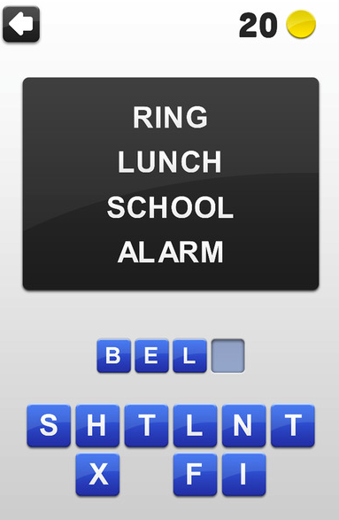

Appendix 3:

